Ideation Phase
Empathize & Discover
Date | 15 Feb 2026
Team ID | LTVIP2026TMIDS66286
Project Name | Gemini Pro Financial Decoder: Transforming Complex Data into Actionable Insights
Maximum Marks | 4 Marks

Empathy Map Canvas
An empathy map helps understand the user’s mindset, challenges, and needs while dealing with complex financial data. This ensures the solution is user-centric and practically useful.
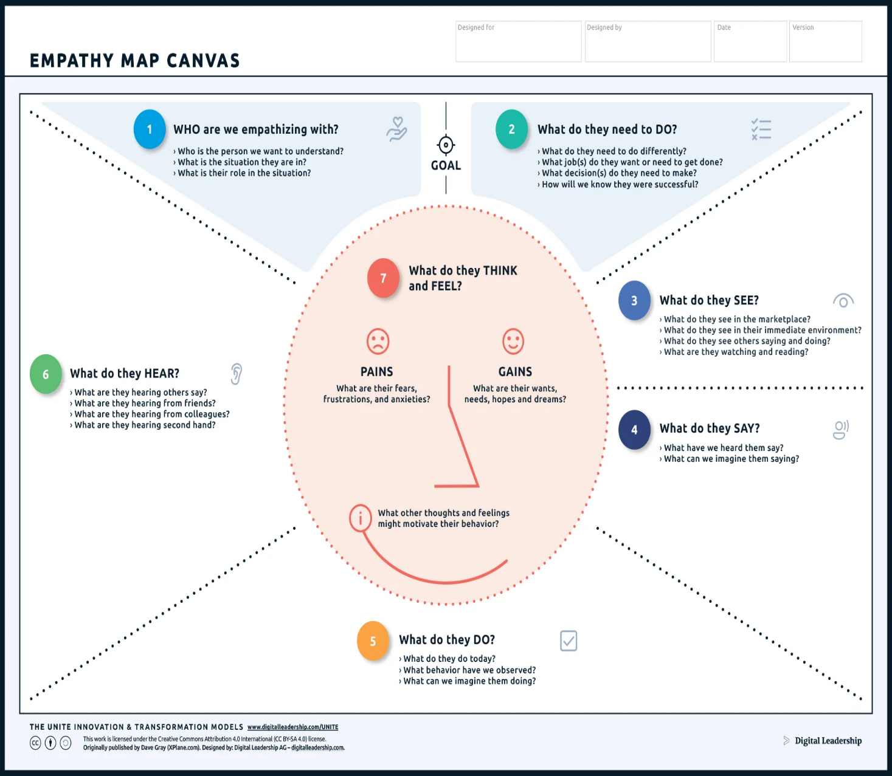
Example:

